Assignment
WEEK -3, DAY-2 – JIRA Interaction

Classroom Task
Test Case Generator: -

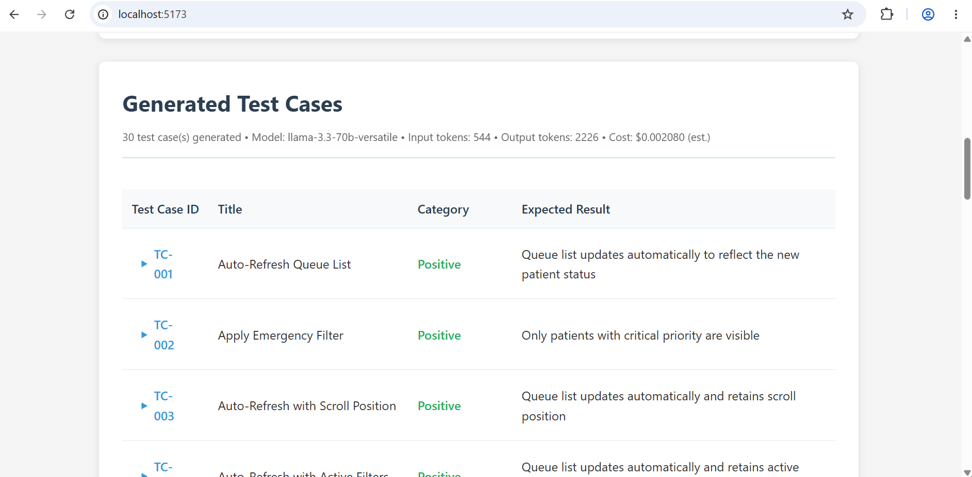

JIRA Implementation
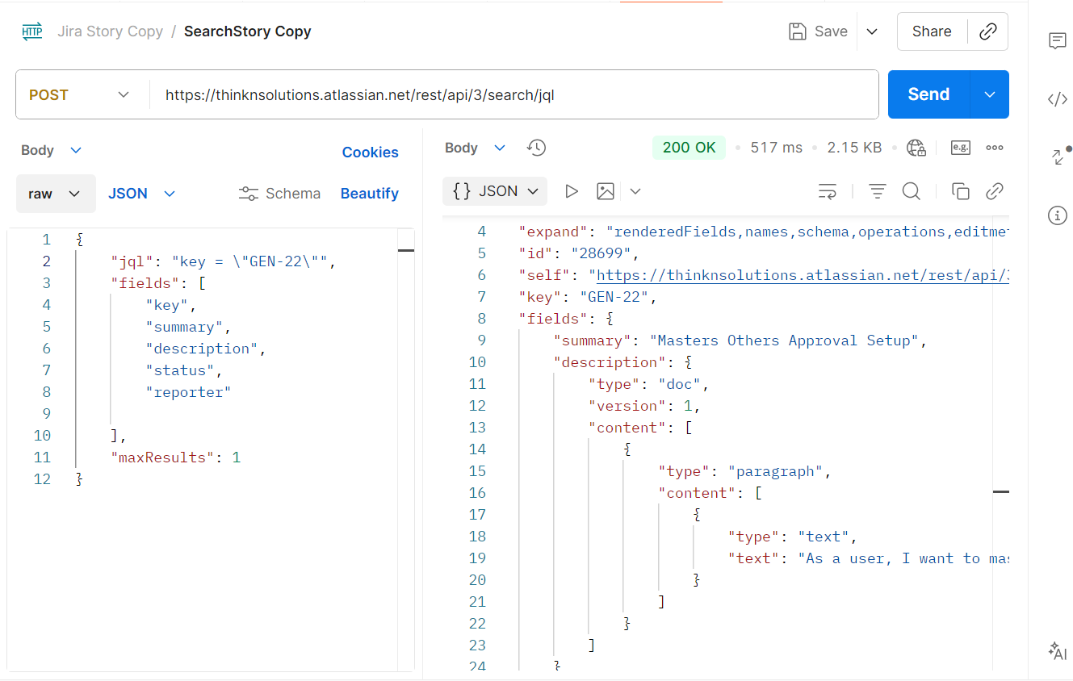
JIRA Connector

Using Copilot (ask) Prompt— Analyse the code and show the impacted and new files for the below implementation Connect to Jira and fetch the user stories implement for both Front end & Back end For the below implementation Go step by step and proceed on my approval with next step Create a connector for Jira in the UI with Email,API token and Connect button Also add the Jira end point to the implementation

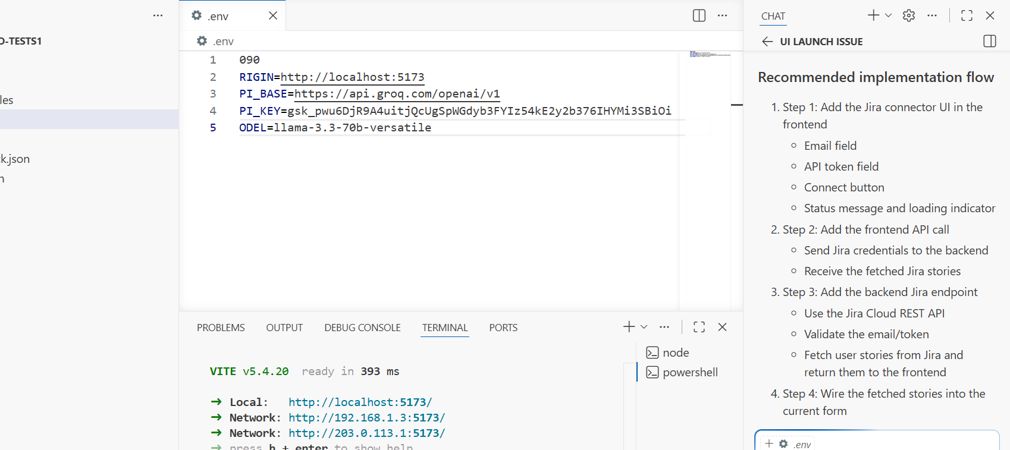

Switching to Agent mode now Prompt:
Implement both front end and back end, go step by step on my approval proceed with next steps always ask for my approval

